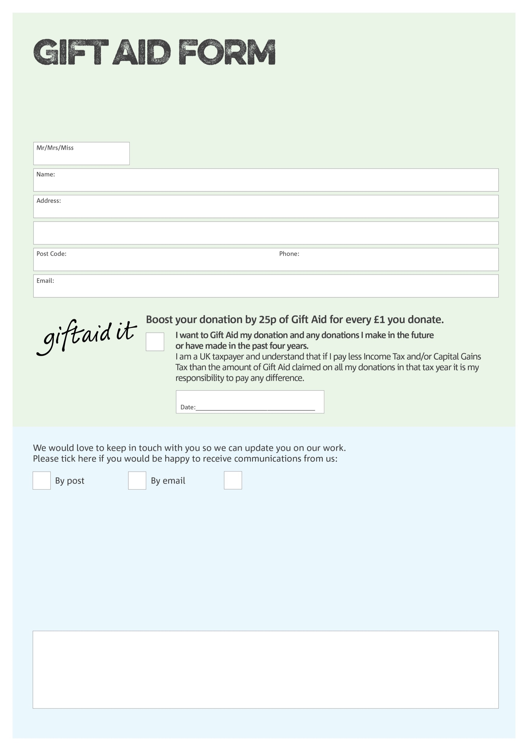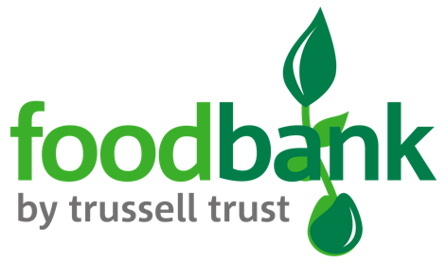F

By filling in this form Flintshire Foodbank will receive an extra 25p for every £1 you give at no extra cost to you. Thank you!

Charity Number 1146921. Registered in England & Wales

You can change your preferences any time by contacting us on 01352 757235 or emailing us at

info@flintshire.foodbank.org.uk

I do not wish to receive future communications from Flintshire Foodbank

**Data protection**

Flintshire Foodbank is committed to protecting your privacy and will process your personal data in accordance with current Data Protection legislation. Flintshire Foodbank collects information to keep in touch with you and supply you with information relating to our work. A full data privacy statement for financial donors is available from the Foodbank on request.

We would love to know why you have chosen to donate to Flintshire Foodbank. If you would like to share your motivation let us know below: